lgbfgfTds k/LIff
sIffM # ljifoM ul0ft

ljBfyL{sf] gfdM ===========================================================================================================================
ljBfnosf] gfdM ================================================================================= lhNnfM ========================== =========================================

tnsf k|Zgx?sf]] pQ/ lbg'xf];\ (Answer the following questions) M

!= tnsf lrqnfO{ s] elgG5 < n]Vg'xf];\ . What are the names of the pictures below? Write. [4]
-ljGb', l;wf /]vf, jqm /]vf, lqe'h, rt'e'{h, j[Q_ (point, straight line, curved line, triangle, quadrilateral, circle)

-s_ |  | -v_ |  | -u_ |  | -3_

@= cª\sdf lbOPsf] ;ª\VofnfO{ g]kfnL cIf/df n]Vg'xf];\ . Write the given numbers in Nepali words.
s_ @# ==================================== [1]
v_ *& =================================== [1]

#= cIf/df lbOPsf] ;ª\VofnfO{ cª\sdf n]Vg'xf];\ . Write the given numbers in figures.
s_ rf}lt; ================================================================================ [1]
v_ ao;6\7L ================================================================================ [1]
u_ Forty seven ================================================================================= [1]

$= 7"nf] ;ª\Vofdf uf]nf] 3]/f -_ nufpg'xf];\ . Circle () the larger number.
-s_ %^ ^% [1]
-v_ () ** [1]

%= hf]/ ;ª\Vofx?df uf]nf] 3]/f -_ nufpg'xf];\ . Circle () even numbers.

$ & ( !% @& *! !* [1]

%_ s'g lx;fjdf 36fp ug'{ k5{ < l7s lrGx -_ nufpg'xf];\ . In which problems should subtraction be used? Mark with a tick mark (). [1]
-s_ x/Ln] !) ?k}ofF a'afaf6 / % ?k}ofF cfdfaf6 lnof] . cj p ;Fu hDdf slt ?lkofF eof] .
Hari take Rs 10 from his father and Rs 5 from his mother. Total how much rupees does Hari have now
-v_ Pp6f ufOsf @ cf]6f l;ª 5g\ eg] !% cf]6f ufOsf sltcf]6f l;ª x'G5g\ <
If one cow has two horns, then how many horns do 15 cows have?
-u_ /fd;Fu #% ?lkofF lyof] . !) ?lkofF vr{ u¥of] . cj slt afFsL 5 <
Ram had Rs. 35 with him. He spent Rs 10. Now how many rupees does he have left?
-3_ %% cf]6f rSn]6 # hgfnfO{ a/fa/ afF8\bf Ps hgfn] slt cf]6f rSn]6 kfpF5g\ <
If 55 chocolates were distributed equally among 3 people, how many chocolates does everyone get?

^= lx;fj ug'{xf];\ . Calculate: [1×4 = 4]
-s_ | @&  + $@ | -v_ | (  − # | -u_ | ^  × # | -3_ | $ @)

&= lrqu|fkm x]/L pQ/ lbg'xf];\ . Examine the pictograph and answer
kmnkm"nx? (fruits) | ;ª\Vof (Numbers)
:ofp (Apple) | 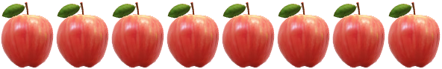
;'Gtnf (Orange) | 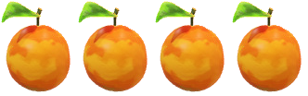
e"O{+s6x/ (pineapple) | 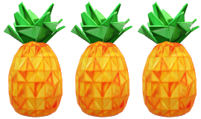
cDaf (Guava) | 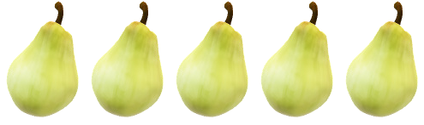

-s_ :ofpsf] ;ª\Vof (Total number of apple?) =========== [1]
-v_ slt k|sf/sf kmnkm'n 5g\ < (How many types of fruits are there?) =========== [1]

